Unit 4 Chemisrty Topic Test: Instrumentation Name: _________________
Mark: /50

Multiple Choice
Question 1
Refer to the graph below to answer this question.
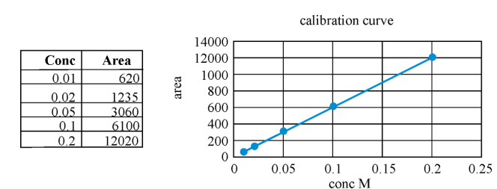

10 mL of ethanoic acid is added to a 500 mL volumetric flask and the flask is made up the mark with deionised water. When the sample is injected into a HPLC, the area under the peak is measured as 600. The concentration of the original ethanoic acid solution is, in M,

- 0.10
- 0.50
- 1.0
- 5.0

Use the following information to answer Questions 2 and 3
A sample of alcohols, which contained a mixture of butan-1-ol (C₄H₁₀O), pentan-1-ol (C₅H₁₂) and hexan-1-ol (C₆H₁₄), was analysed in a HPLC. The chromatogram shown below was obtained. A polar solvent was used.

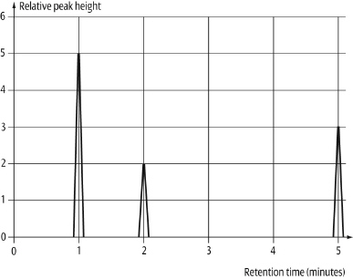
Question 2
In this mixture, it is likely that
- butan-1-ol will have the highest retention time.
- butan-1-ol will have the shortest retention time due to its weaker intramolecular bonding.
- hexan-1-ol will spend the least percentage time adsorbed on the stationary phase.
- hexan-1-ol will have the lowest solubility in the mobile phase.

Question 3
The concentration of each component can be determined by

- comparison of the times each component takes to move through the column.
- comparison of the area under a peak with the that of solutions of known concentrations.
- finding the ratio of the area under each peak.
- comparison of the heights of each peak.

Question 4
A variety of proteins in our bodies can be used as disease markers. Analysts must separate and identify proteins that are used as disease markers from many thousands of proteins that exist in our bodies.
Which of the following sequence of techniques could be used to:
- separate these molecules, then
- determine their molecular structure

- NMR spectroscopy, followed by IR spectroscopy, followed by HPLC
- HPLC, followed by IR spectroscopy, followed by NMR spectroscopy
- HPLC, followed by IR spectroscopy, followed by titration.
- IR spectrometry, followed by NMR, followed by HPLC

Question 5
A mass spectrum of a compound containing carbon, hydrogen and oxygen is shown below.
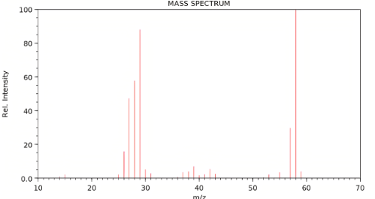

This spectrum could be of

- ethanoic acid
- butanol
- propanal
- propanone

Question 6
The molar mass of a compound is listed as 64.5 g mol⁻¹. The mass spectrum shows two parent molecular ion peaks with the m/z ratios of 64 and 66. The compound is likely to be

- C₂H₅Cl
- C₄H₁₆
- C₅H₆
- C₂H₅O

Question 7
When a molecule absorbs infrared radiation this is most likely to lead to

A. transitions between electronic energy levels in the molecule
B. transitions between vibrational energy levels in the molecule
C. transitions within nuclei of atoms in the molecule when the molecule is placed in a strong
magnetic field
D. the removal of an electron from the molecule leading to the formation of the molecular ion.

Question 8
A sample of ethyl propanoate is prepared from ethanol and propanoic acid. The product is tested to verify there are no traces of either reactant in the ester. The best feature to check on an IR spectrum would be

A. a broad absorption at 3000 cm⁻¹.
B. a broad absorption at 3300 cm⁻¹.
C. no broad absorption above 2600 cm⁻¹.
D. a broad absorption at 1700 cm⁻¹.

Question 9
A high resolution ¹H NMR spectrum is drawn below.
TMS
2.0
11
This NMR could be of

A. ethane
B. ethanol
C. ethanoic acid
D. butane

Question 10
Which of the following molecules has the least number of carbon environments?
- benzene
- ethanol
- propane
- butane

SECTION B - Short-answer questions

Instructions for Section B
Questions must be answered in the spaces provided in this book.
To obtain full marks for your responses you should
- Give simplified answers with an appropriate number of significant figures to all numerical questions; unsimplified answers will not be given full marks.
- Show all workings in your answers to numerical questions. No credit will be given for an incorrect answer unless it is accompanied by details of the working.
Make sure chemical equations are balanced and that the formulas for individual substances include an indication of state; for example, H₂(g); NaCl(s)

Question 1 (6 marks)
High performance liquid chromatography (HPLC) is an analytical technique used for identifying and determining concentrations of components of a mixture.
- HPLC can be both qualitative and quantitative.
- Explain how it can be used qualitatively. 2 marks
________________________________________________________________________
________________________________________________________________________
- Explain how it can be used quantitatively. 2 marks
________________________________________________________________________
________________________________________________________________________

- List three factors that will affect the retention times of components in a mixture when it is passed through the column. 2 marks

________________________________________________________________________
________________________________________________________________________

Question 2 (9 marks)
a. The isomers of propanol shown below can easily be distinguished using NMR.

i. Will these two molecules have similar chemical properties? Discuss your answer, referring
to properties. 2 marks

_________________________________________________________________________

________________________________________________________________________

________________________________________________________________________

ii. How will the proton-MNR spectra compare? Discuss your answer. 3 marks

_________________________________________________________________________

________________________________________________________________________

________________________________________________________________________

________________________________________________________________________

iii. How will the C-NMR spectra compare? 2 marks

________________________________________________________________________

________________________________________________________________________

b. This year, NMR peak area ratios are expected knowledge. Refer to the first propanol isomer
shown above to describe the area ratios the proton spectra will show. 2 marks

________________________________________________________________________

________________________________________________________________________

________________________________________________________________________

Question 3 (9 marks)
Infrared spectroscopy is a technique used to help determine the types of functional groups present in unknown compounds. Each compound can produce a unique spectrum that can be used to identify it.
The IR spectra of butane, butanol and butanoic acid are below.

Spectra A Spectra B
Spectra C

- Identify the compound that produces each spectra.

- Spectra A:__________________________ 1 mark
- Spectra B:__________________________ 1 mark
- Spectra C:__________________________ 1 mark
- Provide evidence for your selections.
- Spectra A: 2 marks
____________________________________________________________________________________________________________________________________

- Spectra B: 2 marks
____________________________________________________________________________________________________________________________________

- Spectra C: 2 marks
____________________________________________________________________________________________________________________________________

Question 4 (9 marks)

The proton-NMR and infrared spectra of an organic compound are shown below.
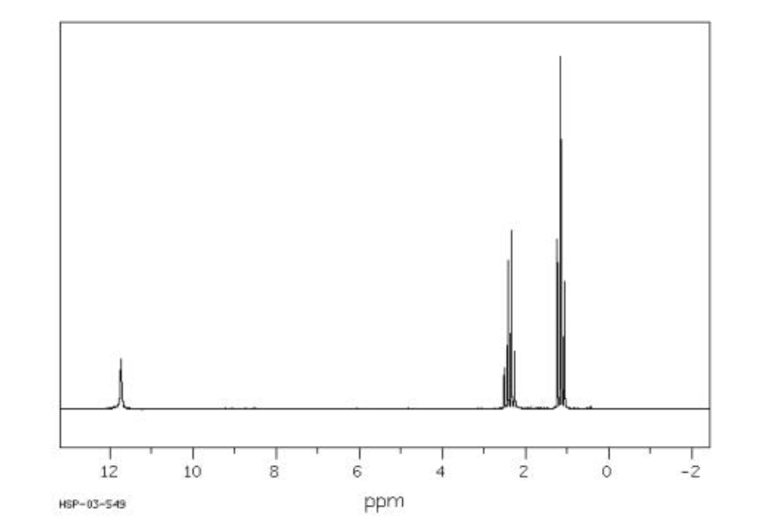

proton-NMR

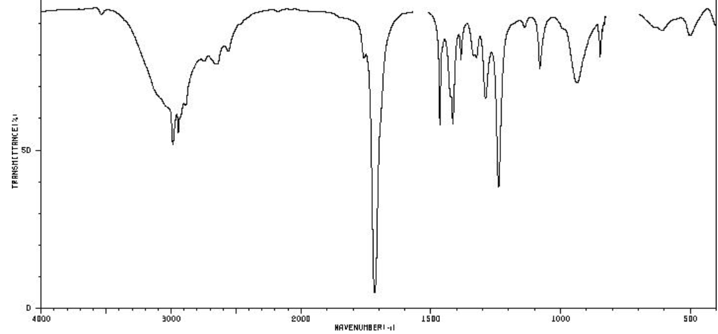
IR Spectrum

a. i. The compound is known to contain more than one oxygen atom. Determine the molecular
formula of the compound if the molar mass is 74 g mol⁻¹. 2 marks

________________________________________________________________________
________________________________________________________________________

ii. Draw three possible structures with this molecular formula. 3 marks

b. How many different proton environments are there in this molecule? ______ 1 mark

c. i. Draw the structure of the unknown molecule, showing all bonds. 2 mark

- Name the molecule. __________________________ 1 mark

Question 5 (7 marks)
The mass spectra of another organic compound is drawn below. The compound contains one oxygen atom.
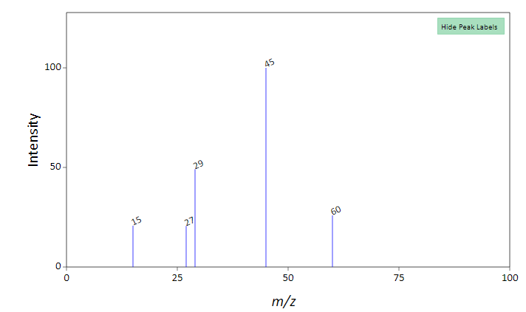
a. What is the molecular formula of the compound? _____________________________ 1 mark

b. The infrared spectrum is shown below.
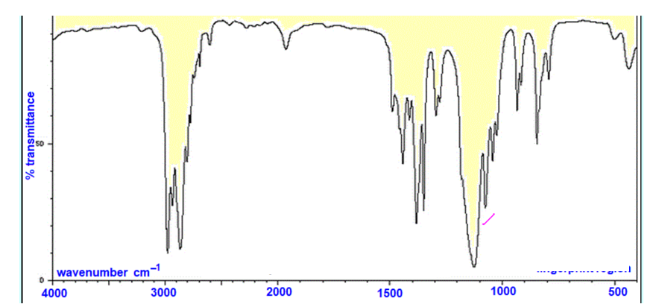

State two conclusions you can draw from this spectrum. 2 marks

___________________________________________________________________________

___________________________________________________________________________

___________________________________________________________________________

c. The proton-NMR of this compound is shown below.
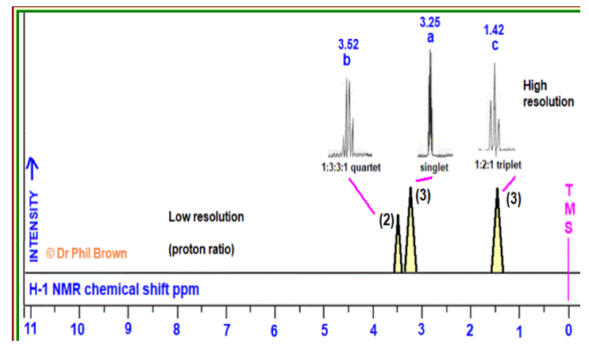

Draw a structure for this compound that is consistent with the information provided. Justify
your answer, including reference to the peak areas provided on the spectrum. 4 marks

___________________________________________________________________________

___________________________________________________________________________

___________________________________________________________________________

___________________________________________________________________________

END OF TASK

